The 2017 annual Pipe Lakes Boat Parade was a success again this year. On Saturday, July 1 we had good weather and 8 boats participate. Thanks to all the families who made the effort to be involved. Spectators and participants had a fun and noisy time!

We had 4 categories for trophies and the 1st place winners were:

Best Theme – the McCarthy boat “Wonder Woman”
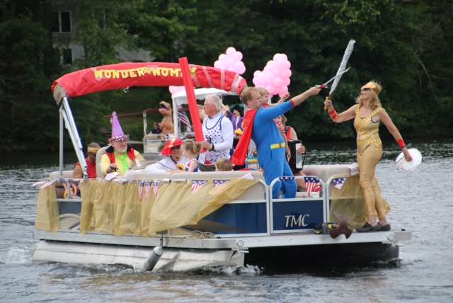

Most Creative –the Wenger boat, “ S S Despicable Me 3”
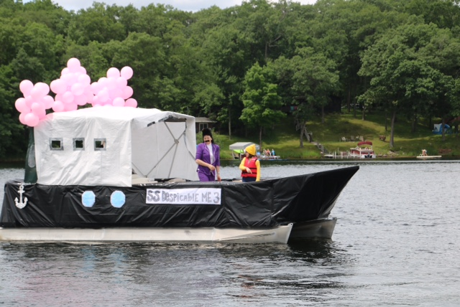

Most Patriotic – the Norquist boat , “USA”
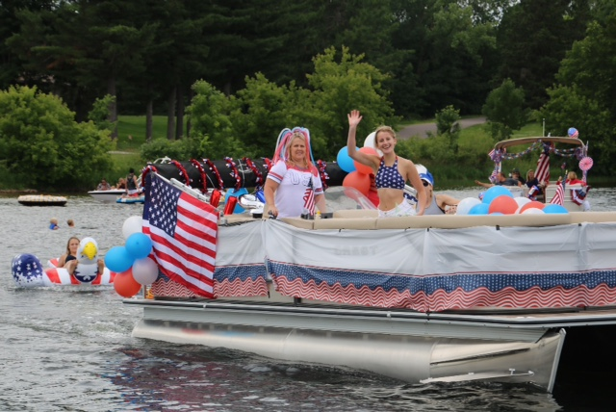

Most Enthusiastic – the Jenson boat “Costume Party”
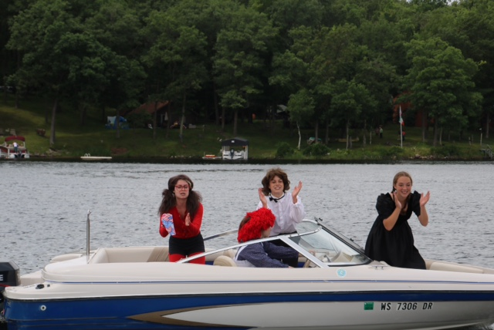

Thanks everyone for helping to make the Pie Lakes Boat Parade the best.

